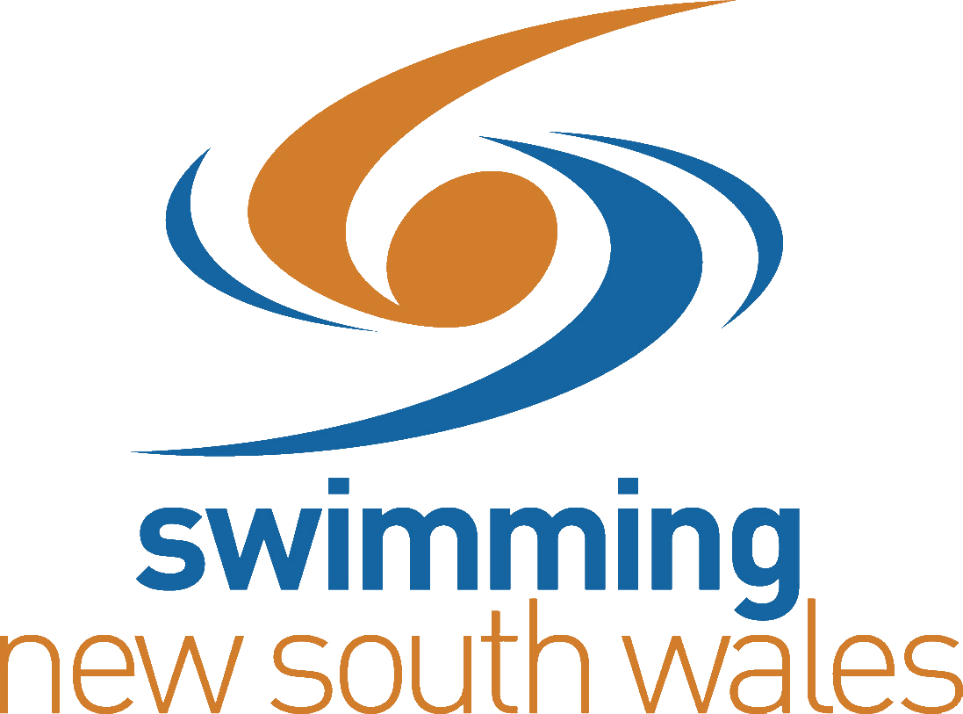
SCHOOLS/ZONE SWIM MEET APPROVAL FORM

School/Zone Meet Name: __________________________________________________________
School Meet Date: ______________________________________________________________
Venue (Address): ______________________________________________________________
Name of Qualified ______________________________________________________________
Referee booked to attend:

Name of Qualified ______________________________________________________________
Starter booked to attend:
Electronic Timing Equipment to be used at meet Yes No
School Meet Nominated Contact (Name): ____________________________________________
Contact Numbers: _________________________ ________________________________
Email Address: _____________________________________________________________
I, ____________________, will send the following information to admin@nsw.swimming.org.au within 7 days after the date of the meet*, in order for results to be uploaded to the National Results Database (NRD):
- Date/s of meet
- Meet Manager Back Up File and Team Manager Results File
- Name of Referee who attended
- Name of Starter
- Meet code in ClubLANE
Signed: ___________________________________________________________
Please send to:
admin@nsw.swimming.org.au
For any queries, please contact Swimming NSW on (02) 9763 5833.
*for the avoidance of doubt, this is a period of 168 hours, commencing from 12am on the day following the conclusion of the meet.

