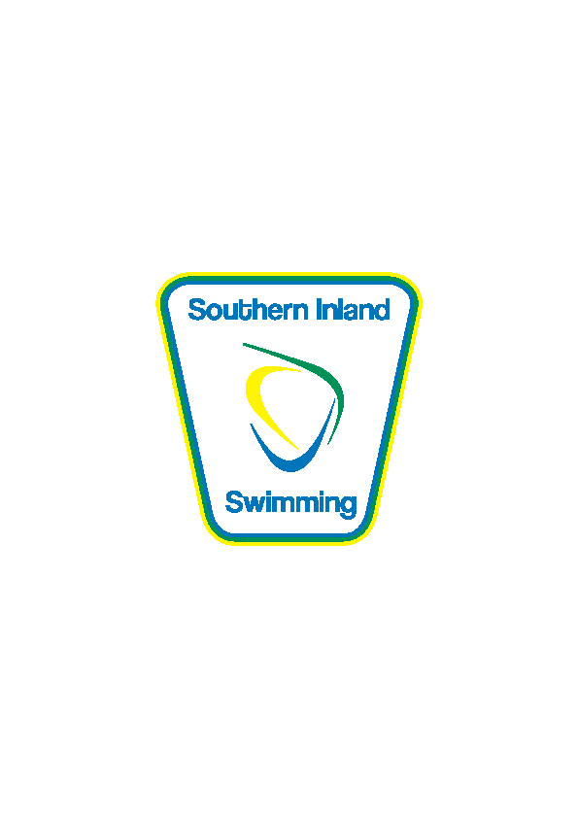SOUTHERN INLAND SWIMMING ASSOCIATION INC.
DENILIQUIN A.S. & LSC Inc.
Saturday 11th January, 2020. Warm up 11:00 am: Start time 12:00noon
Deniliquin Swim Centre, Poictiers Street, Deniliquin.
Entry Fee $6:00 per individual event. Relays no charge – enter on day Age as at day of meet.
Online https://connect.swimming.org.au/sal-wrap-public/workflows/MEMBER.EVENT.DETAIL&dbWorkflowKey=021517
Entries close 7th January 2020
All events are timed finals. SNSW & SAL Rules apply. Medals for 1st, 2nd and 3rd placegetters.
***Competitors in 7 & under 25m events are not permitted to swim other events in that stroke. No refunds given.
Age groups events are conducted concurrently as timed finals.
******Come and try & Swimmers with disabilities may enter 25m events on the day*******.
Enquires to Chris Hayes on 0427961305

Male | Female | Age group | Distance | Stroke
1 | 2 | Open | 200m | Freestyle
3 | 4 | 7 & under *** | 25 | Freestyle
5 | 6 | 8 & under | 50 | Freestyle
 |  | 9/10 | 50 | Freestyle
 |  | 11/12 | 50 | Freestyle
 |  | 13/14 | 50 | Freestyle
 |  | 15 & over | 50 | Freestyle
7 | 8 | 9 & under | 100 | Breaststroke
 |  | 10/11 | 100 | Breaststroke
 |  | 12/13 | 100 | Breaststroke
 |  | 14 & over | 100 | Breaststroke
9 | 10 | 7 & under *** | 25 | Backstroke
11 | 12 | 8 & under | 50 | Backstroke
 |  | 9/10 | 50 | Backstroke
 |  | 11/12 | 50 | Backstroke
 |  | 13/14 | 50 | Backstroke
 |  | 15 & over | 50 | Backstroke
13 | 14 | 11 & under | 100 | Butterfly
 |  | 12/13 | 100 | Butterfly
 |  | 14 & over | 100 | Butterfly
15 | 16 | 7 & under *** | 25 | Breaststroke
17 | 18 | 8 & under | 50 | Breaststroke
 |  | 9/10 | 50 | Breaststroke
 |  | 11/12 | 50 | Breaststroke
 |  | 13/14 | 50 | Breaststroke
 |  | 15 & over | 50 | Breaststroke
19 | 20 | 9 & under | 100 | Backstroke
 |  | 10/11 | 100 | Backstroke
 |  | 12/13 | 100 | Backstroke
 |  | 14 & over | 100 | Backstroke
21 | 22 | 7 & under *** | 25 | Butterfly
23 | 24 | 8 & under | 50 | Butterfly
 |  | 9/10 | 50 | Butterfly
 |  | 11/12 | 50 | Butterfly
 |  | 13/14 | 50 | Butterfly
 |  | 15 & over | 50 | Butterfly
25 | 26 | 9 & under | 100 | Freestyle
 |  | 10/11 | 100 | Freestyle
 |  | 12/13 | 100 | Freestyle
 |  | 14 & over | 100 | Freestyle
27 | 28 | 9 & under | 200 | Individual Medley
 |  | 10/11 | 200 | Individual Medley
 |  | 12/13 | 200 | Individual Medley
 |  | 14 & over | 200 | Individual Medley
29 | 30 | Open | 400 | Freestyle
31 | 32 | Club Relay 4 x 50m | 200 | Freestyle Relay

