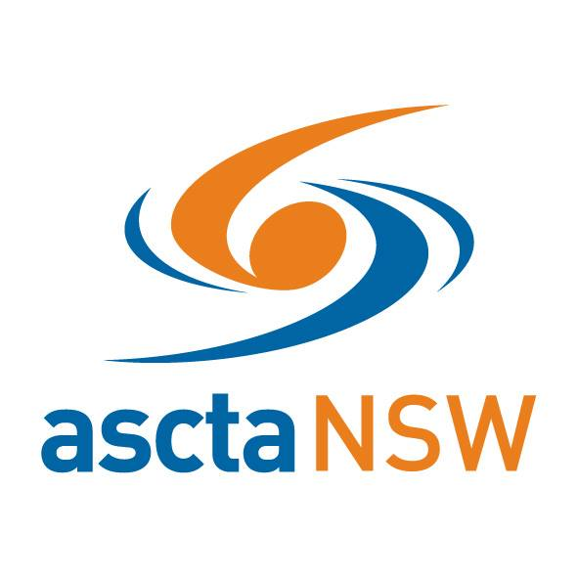
Swim Australia (NSW) Outstanding Service to Teaching
2018 Award Nomination Application
Nominations are called for the 2018 Swim Australia (NSW) Outstanding Service to Teaching award, to be presented at the asctaNSW awards ceremony on 23rd February 2019 at the Novotel Sydney Olympic Park.
GENERAL INFORMATION
The nomination for the 2018 Swim Australia (NSW) Outstanding Service to Teaching award can be submitted by anyone - colleagues, clients, friends etc.
Award winners will be at the discretion of the selection committee based on deserving applicants who meet the criteria.
ELIGIBILITY:
To be eligible for an award the nominee must hold:-
• a current ascta membership
• a current and appropriate Swim Australia Teacher accreditation
• employment with a Swim Australia registered swim school
SELECTION CRITERIA TO BE ADDRESSED:
• Personal Attributes, Outstanding achievements
• Teaching Experience
• Professional Development
• Leadership
The nomination must identify the nominee’s significant experience and/or knowledge in all areas of the selection criteria

Applications to be submitted by close of business Friday 11th January 2019 to:
Darren Howard: darren.howard@nsw.swimming.org.au
Swim Australia (NSW) Teacher of the Year 2018 Award Nomination Application
1. NOMINEE INFORMATION
Please Print
First Name: | Last Name:
Postal Address:
Suburb: |  | Postcode:
Contact Number:
Email address:
Ascta Membership Number:
Swim School:
Years of Teaching:
Swim Australia Teacher Accreditations: Swim Australia Teacher
Swim Australia Teacher of Babies & Toddlers Swim Australia Teacher of Adults & Adolescents
Swim Australia Teacher of Learners with a Disability
Swim Australia Teacher of Culturally and Linguistically Diverse
Nominee has been notified and agreed to being nominated Yes

2. NOMINATED BY
First Name: | Last Name:
Postal Address:
Suburb: |  | Postcode:
Contact Number:
Email address:
Ascta Membership Number:
Swim School:
Association to Nominee:
Do you certify that the information provided on support of this nomination is true and accurate? Yes
3. LENGTH OF SERVICE
Years of industry experience as a Swim Teacher:
Current average hours per week working in the aquatic industry as a Swim Teacher:
Please address each of the following criteria in 200 words or less (provide attachments if extra space is required)
4. PERSONAL ATTRIBUTES
Provide clear examples and evidence that support the nominee’s personal attributes to teaching in relation to communication skills, positive attitude, lesson presentation and preparation:
5. TEACHER EXPERIENCE
Provide clear examples and evidence that support the nominee’s teaching extent of knowledge and experience across multiple teaching disciplines, for example Babies, Toddlers, Adults, Learner with Disability:
6. PROFESSIONAL DEVELOPMENT
Provide clear examples and evidence that demonstrate the nominee’s commitment to professional development above and beyond that required for Swim Australia Teacher accreditation:
7. LEADERSHIP
Provide clear examples and evidence that demonstrate the nominee’s commitment to the training and development of other teachers:
Please attach a clear photograph of the nominee

