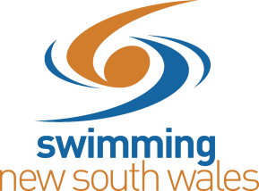
SCHOOLS/ZONE SWIM MEET APPROVAL FORM

School/Zone Meet Name: Click or tap here to enter text.

School/Zone Meet Date: Click or tap here to enter text.

Name of Pool: Click or tap here to enter text.

Name of Qualified Referee: Click or tap here to enter text.

Name of Qualified Starter: Click or tap here to enter text.

Meet Contact Name: Click or tap here to enter text.

Contact Numbers: Click or tap here to enter text.

Email Address: Click or tap here to enter text.

The meet organisers will send the following information to results@nsw.swimming.org.au within 7
days after the date of the meet*, for results to be uploaded.

- Date/s of meet
- Meet Manager Back Up File
- Results for TM (.zip file)
- PDF copy of the post-event athlete entry count
  - Using MM, open Reports Team tick Athlete Entry Count click Create Report
- The names of both the currently accredited Referee and Starter that officiated at the meet

*for the avoidance of doubt, this is a period of 168 hours, commencing from 12am on the day following the conclusion of the meet.

Signed: Click or tap here to enter text.

Date: Click or tap here to enter text.

For any queries, please email results@nsw.swimming.org.au

Should you require timing equipment at this meet, please complete this form and send to finance@nsw.swimming.org.au.

