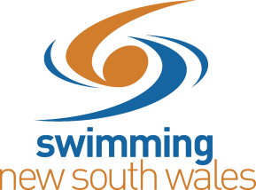
SCHOOLS TECHNICAL OFFICIAL REQUEST FORM
There is a fee of $50 per Technical Official sought via the Swimming NSW office. If you wish to ensure your swim meet is recognized for the purpose of achieving qualifying standards for subsequent meets, please ensure you make note of the School Swim Meet Policy which lists the requirements, and request the relevant officials should they not already be organised.

School/Zone Name: Click or tap here to enter text.
School Meet Date: Click or tap here to enter text.
Venue (Address): Click or tap here to enter text.
Time of Meet: Click or tap here to enter text.
Parking Instructions: Click or tap here to enter text.

Please type ‘Yes’ in the relevant spaces if a certain official is required.
Referee (and number required) Click or tap here to enter text.
Starter (and number required) Click or tap here to enter text.
Timekeepers (and number required) Click or tap here to enter text.
Other Click or tap here to enter text.

School Meet Nominated Contact (Name): Click or tap here to enter text.
Contact Number: Click or tap here to enter text.
Email: Click or tap here to enter text.
Please complete and send it to results@nsw.swimming.org.au. For any queries, please contact Swimming NSW on (02) 9763 5833.
Should you require timing equipment at this meet, please complete this form and send to finance@nsw.swimming.org.au

